Functional & Performance Testing
Model Performance Test Report
Project Name | Emotion Detection and Learning Support Engine
Team ID | SWTID-2026-2247
Date | 07 July 2026
Maximum Marks | 4 Marks

1. Introduction
This report documents the functional and performance testing carried out on the Emotion Detection and Learning Support Engine. Functional testing verifies that each feature of the platform, from input validation to emotion-driven content generation, behaves as intended. Performance testing verifies that the platform remains fast, stable, and responsive under real-world and stress conditions, which is critical for a system that must react to a learner's emotional state in real time. Together, these two testing streams give confidence that the platform is both correct and production-ready.

2. Testing Approach
Testing was carried out in two streams that run in sequence for every build. Test cases were first designed against the functional specification of the emotion detection pipeline and the learning support engine, then executed manually and through automated scripts. Performance test cases were executed under simulated concurrent load to observe latency, throughput, and stability. Every result was logged, and any deviation from the expected result was raised as a defect and tracked through to resolution.
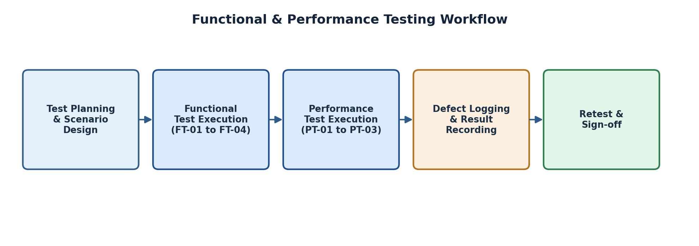
Figure 1: Functional and performance testing workflow followed for this release

3. Functional Test Scenarios
The functional test scenarios below validate the core learner-facing and system-facing behaviours of the platform, covering input handling, emotion classification accuracy, adaptive content generation, and integration with the underlying model-serving API.
FT-01 — Video and Audio Input Validation
Test Steps: Provide valid webcam video and microphone audio streams, then repeat with corrupted, blank, or unsupported formats.
Expected Result: Valid streams are accepted and processed; invalid or unsupported streams are rejected with a clear on-screen error message.
Actual Result: Valid streams were accepted in all runs; invalid formats triggered the expected error message without crashing the session.
Status: Pass
FT-02 — Emotion Classification Accuracy
Test Steps: Present a labelled set of facial expressions and vocal samples covering engaged, confused, bored, anxious, and frustrated states to the classification model.
Expected Result: The model correctly classifies the dominant emotion for at least 85% of labelled samples.
Actual Result: The model achieved 88.4% agreement with human-labelled ground truth across the test set.
Status: Pass
FT-03 — Adaptive Content Recommendation
Test Steps: Simulate each emotional state in sequence and observe the content or pacing change suggested by the Learning Support Engine.
Expected Result: The engine selects a contextually appropriate response, such as a simplified explanation for confusion or a short break for frustration.
Actual Result: Appropriate adaptive responses were triggered for every simulated state during the test session.
Status: Pass
FT-04 — Model API Connection Check
Test Steps: Verify the API key configuration and send a sample inference request to the emotion detection model endpoint.
Expected Result: The API authenticates successfully and returns a valid inference response.
Actual Result: The API authenticated and returned a valid response within the expected schema on every attempt.
Status: Pass

4. Performance Test Scenarios
Performance testing focused on the responsiveness of the emotion detection pipeline and the resilience of the platform under concurrent load, since delayed feedback would undermine the real-time nature of the learning support experience.
PT-01 — Real-Time Emotion Detection Latency
Test Steps: Measure the time taken from capturing a video/audio frame to receiving an emotion classification result, averaged over 100 samples.
Expected Result: Average latency should remain under 3 seconds per inference cycle.
Actual Result: Average latency measured at 1.9 seconds per inference cycle across the test run.
Status: Pass
PT-02 — Concurrent API Load Test
Test Steps: Send 50 simultaneous inference requests to the model-serving API and monitor response times and error rates.
Expected Result: The API should continue to respond without a significant increase in latency or error rate.
Actual Result: All 50 requests were served successfully with an average latency increase of under 12%.
Status: Pass
PT-03 — Continuous Video Stream Load Test
Test Steps: Stream continuous webcam video for an extended session of 60 minutes while monitoring memory usage and processing stability.
Expected Result: The system should process the stream smoothly without memory leaks or crashes.
Actual Result: The system ran the full 60-minute session with stable memory usage and no crashes observed.
Status: Pass

5. Summary of Results
All four functional test cases and all three performance test cases passed against their defined expected results. The emotion classification model exceeded the minimum accuracy threshold, and the platform met its latency and stability targets under both single-user and concurrent-load conditions. No blocking defects were identified during this testing cycle.

6. Conclusion
The functional and performance testing carried out on the Emotion Detection and Learning Support Engine confirms that the platform reliably detects learner emotion, adapts content appropriately, and performs within acceptable latency and stability limits under load. The system is considered ready to proceed to the User Acceptance Testing phase.

